**Instructions for Electronics**

**Materials**

- Arduino Leonardo

- Arduino Prototyping Shield

- 10 mm RGB LED

- 10 mm yellow LED

- 330 Ω resistor

- 150 Ω resistor

- two 100 Ω resistors

- Heat shrink

- Solid core 22 or 24 gauge wire in black, red, and 3 other assorted colors, ideally yellow, green, and blue.

See the parts list spreadsheet on where you can order these supplies and some specific parts numbers.

**Tools**

- Soldering iron + accessories (solder, tip cleaning wire sponge, etc)

- Clip of some sort to hold electronics in place while soldering

- Wire strippers

- Wire snippers

- Heat gun for the heat shrink

**Instructions**

Begin by prepping the wire that you will need. You will need:

- Two 4-inch pieces of black wire. Strip the ends of each piece of wire (see picture below).

- One 4-inch piece of each red, green, blue, and yellow wire. (The colors of the wire don't actually matter as long as you keep track of what connects to what.)

- One shorter (maybe 2") piece of black wire.

- Two pieces of "jumper" (~1/2") black wire.

First, we will prep the prototyping shield. The shield in the PartsList.xlxs file works with our Leonardos. The two images ShieldFront.jpg and ShieldBack.jpg show pictures of the assembled shield we are using, although as noted these instructions suggest using a different choice of color for some of the wires.

Snip the male-to-male headers into four pieces to match the width of the four blocks of female headers on the Arduino Leonardo. A picture of the snipped headers is shown below along with the shield as it arrives. The picture also shows the shorter black wires we'll need to solder onto the shield.

Next, solder the headers into the prototyping shield such that it matches the Leonardo and can be used as a shield for the Leonardo. If you are struggling to ensure they line up perfectly, stick the male-to-male headers into the Leonardo's female headers, and wiggle the prototyping shield so that the holes align with the male headers that are sticking up. Then, proceed to solder the male-to-male headers in, with the Leonardo serving to hold them in place. We just need the headers soldered in - there are other parts that come with the shield, but we are not using them and we don't need to mount them.

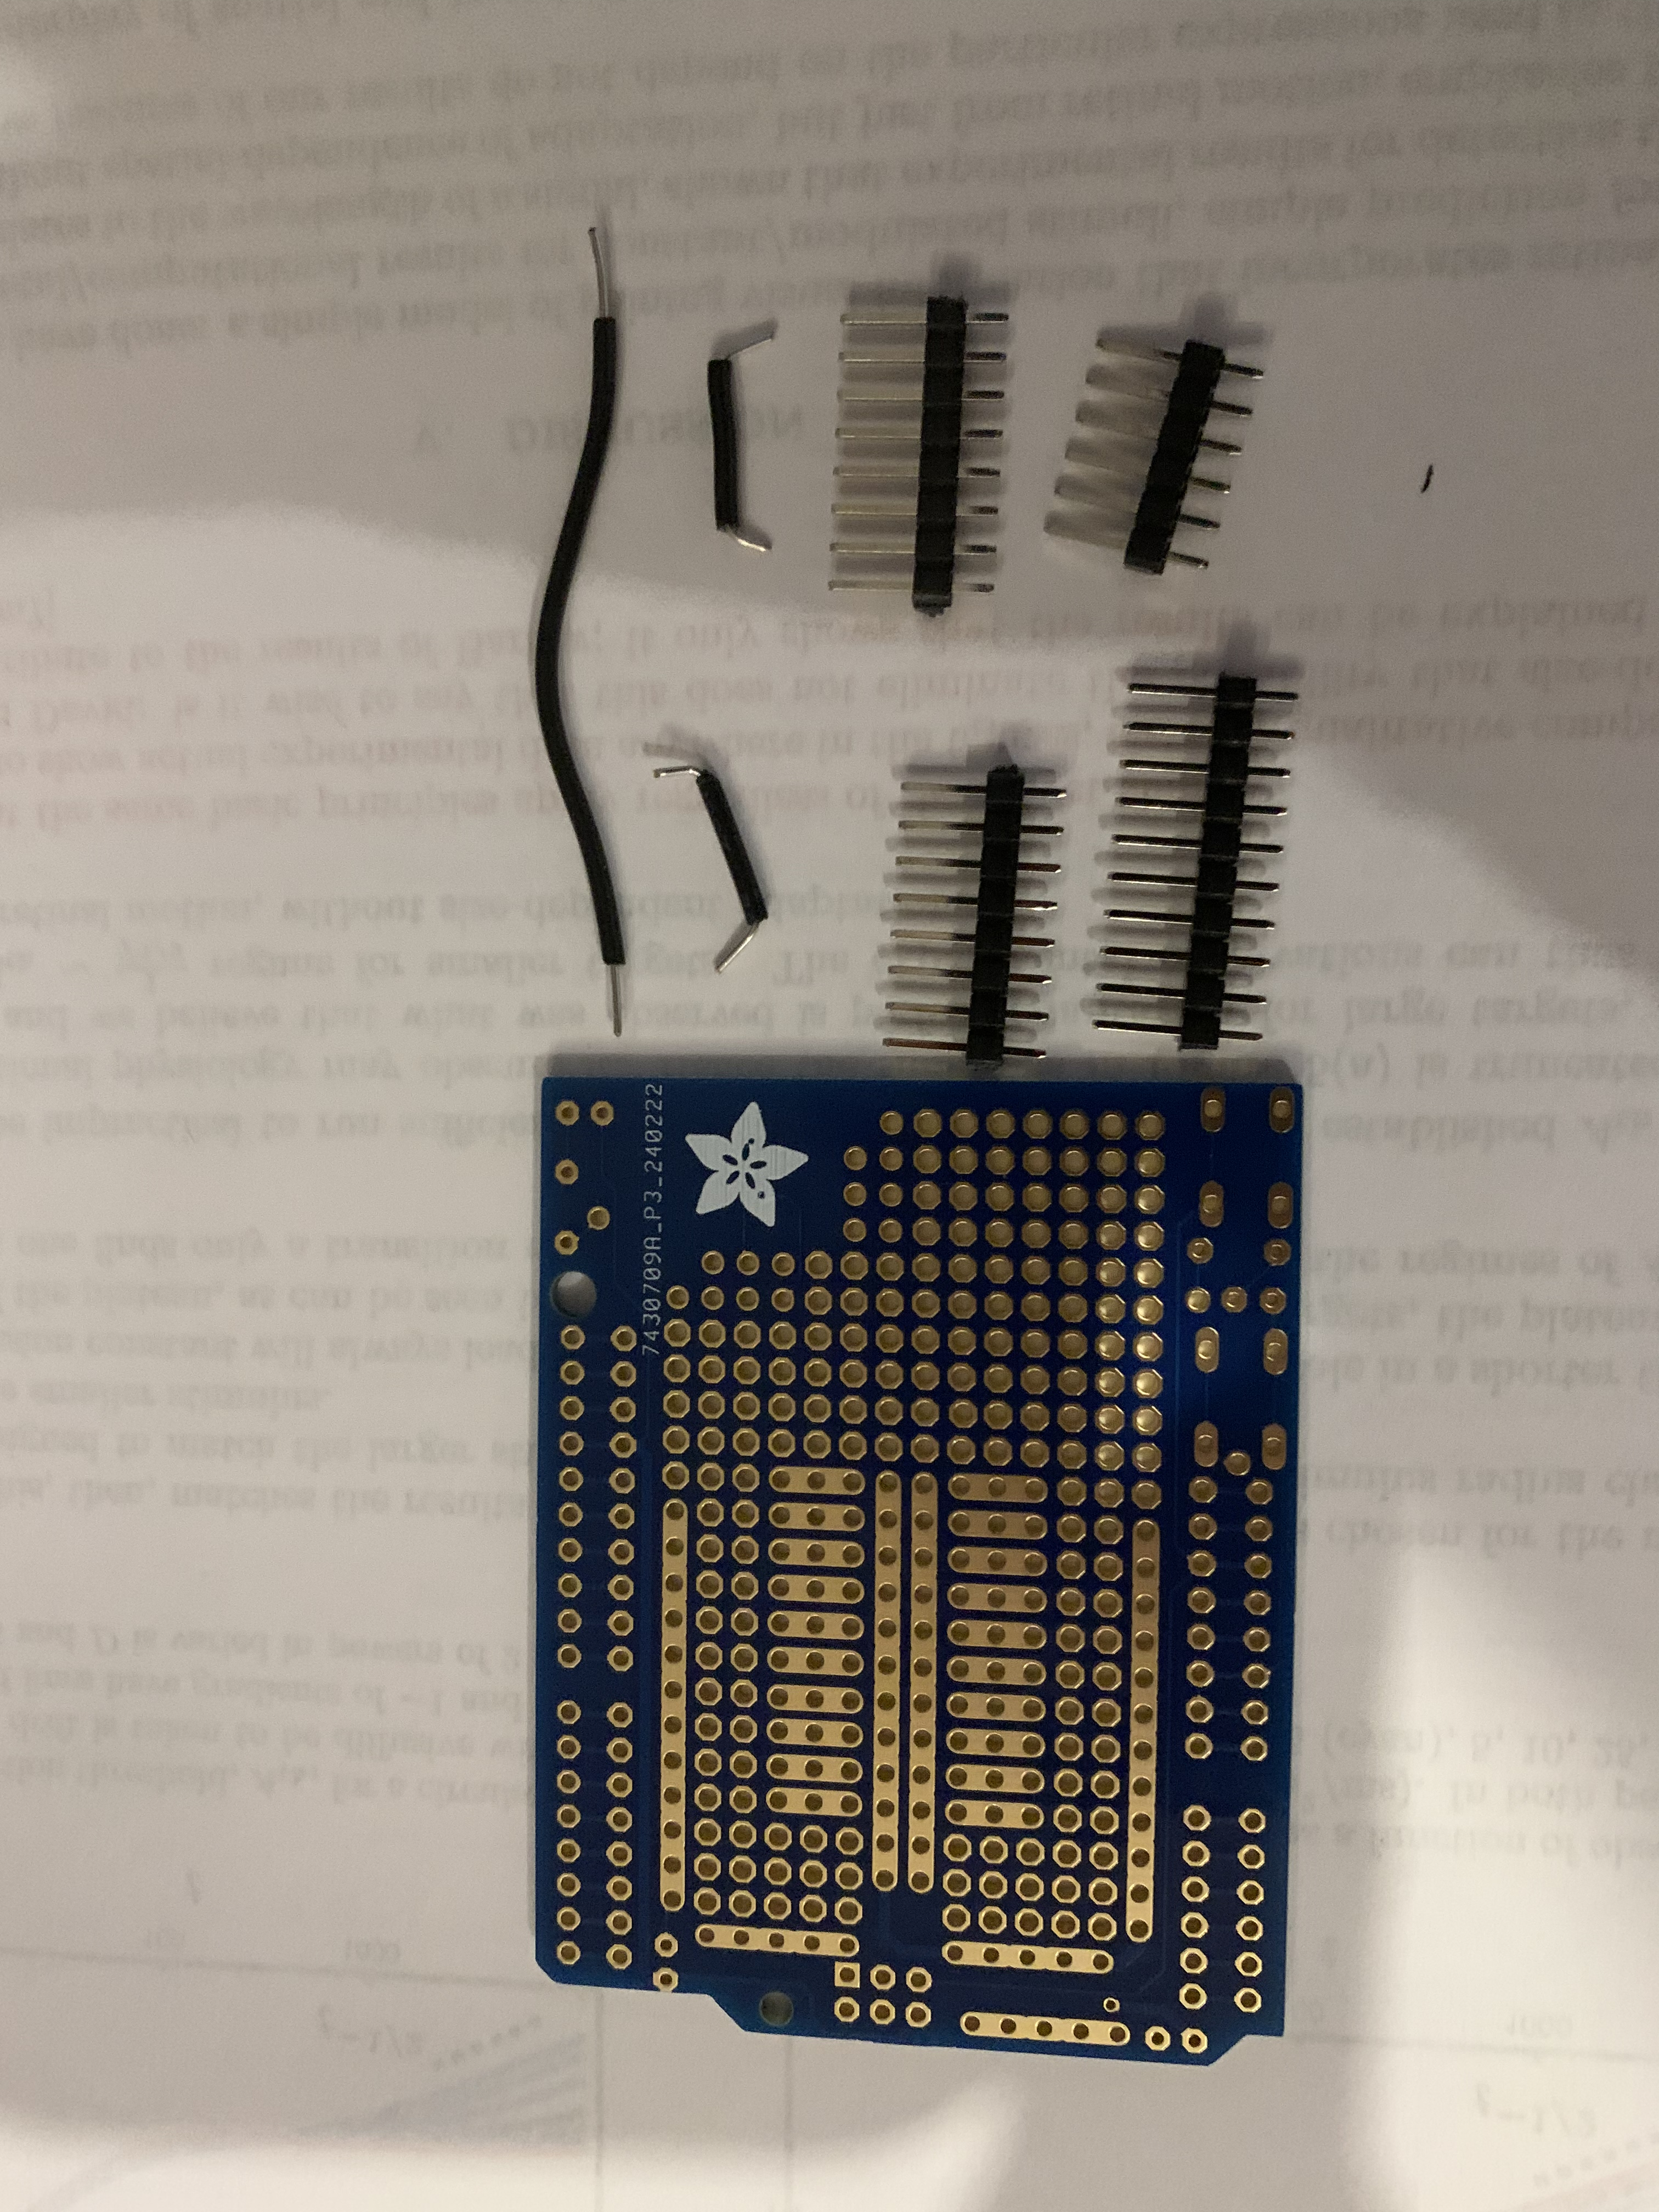

Once the prototyping shield is prepped, we can move to the LEDs. This picture shows the two LEDs and the color wires that should attach to each lead. For the yellow LED, the black wire should go on the longer (anode) lead on the left as shown, and the yellow wire on the shorter cathode lead.

Begin with the yellow LED. Note that the positive leg of the LED is longer. Solder a black wire to this longer positive (aka anode) leg and a yellow wire to the shorter negative aka (cathode) leg. This is as shown in the picture below. It may be hard to see in the picture, but the lead on the left in the picture is in fact longer than the one in the right.

Once finished, make sure to push heat shrink over each of the exposed wires, up to the bottom of the LED, and use the heat gun to attach it.

Next, do the same with the RGB LED. Solder a red wire to the red LED, a white wire to the positive leg (the longest), a green wire to the green LED, and a blue wire to the blue LED. This is as shown in the picture below. It may be hard to see in the picture, but the lead second from the left is the longest. If you blow up the picture, you can also see the colors of the resistors that indicate which are which. In the picture, the 330 ohm is shown by the yellow wire, the 150 ohm by the red wire, and the remaining two are both 100 ohm.

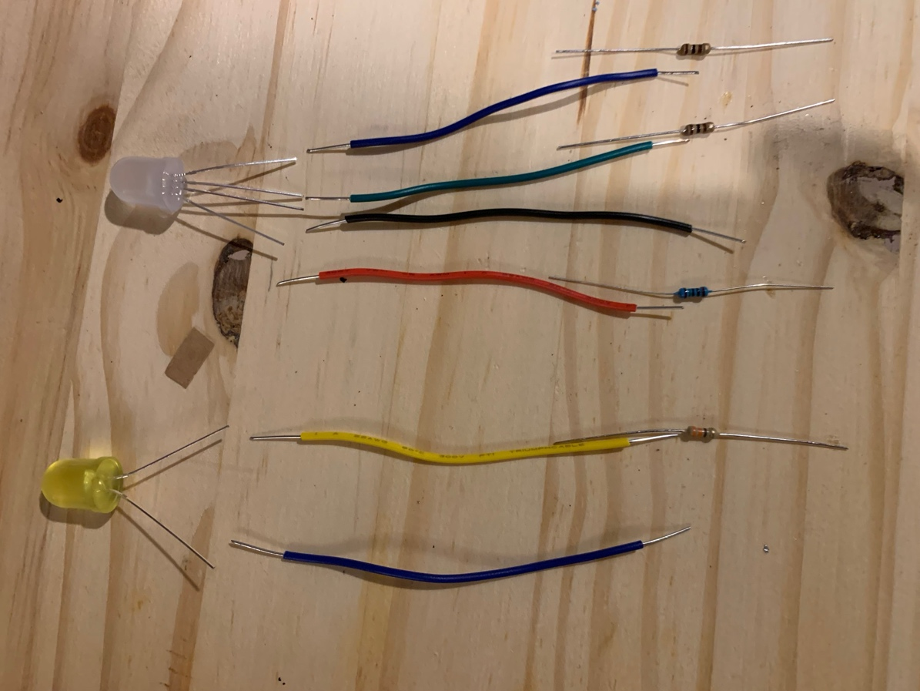

Finally, you need to solder the LEDs to the Arduino shield. How this happens will depend on the specifics of the Arduino shield you use, but the following must be true:

For the RGB LED, the red leg must connect through a 150 ohm resistsor to D6, the green leg through a 100 ohm resistor to D5, and the blue leg through a 100 ohm resistor to D3. The black needs to connect to +5V. For the yellow LED, the positive leg (black wire) must connect to +5V, and the negative leg (yellow wire) through a 330 ohm resistor to D9.

See the wiring diagram at the end, and also pictures below that show one way to wire this all up on the shield. Note that the instructions above suggest using black wire for the one on the back and the two short jumper wires, which are in red wire in the picture. Keeping them all black means that all the black wires connect up to +5V, and none of the other colored wires do. Our resistors are also colored differently from the ones in this picture.